SECTION EA

MAINTENANCE SCHEDULE

THE ADOPTION OF A PLANNED SCHEDULE OF MAINTENANCE, BASED ON OPERATING REQUIREMENTS, IS IMPORTANT IF A CONSISTENTLY HIGH STANDARD OF PERFORMANCE AND RELIABILITY IS TO BE ACHIEVED.

OVERHAUL PERIODS

Overhaul periods are dependent on the duty that an engine is actually subjected to, and therefore the most appropriate figures for a given installation can only come from experience. Our recommended periods for new installations are:-

6000 hours for a top overhaul  
12000 hours for a major overhaul

These figures can be adjusted on the basis of the first strip examination and may be biased to suit the refit requirements of the application.

If a precise duty profile is available, engineering department can advise whether these periods can be extended.

Whilst the schedule indicates the maintenance required, the correct method of carrying out the work is given in the appropriate manual section. Reference MUST be made to the correct section to ensure that errors do not occur which may cause damage to the components.

Engine Log

Engine operators are recommended to keep a log book recording the total engine running hours, exhaust temperatures, oil and water temperatures and/or pressures, and fuel and lubricating oil consumption. Periodical inspection, adjustments and replacements of parts should also be included for reference when investigating faults and planning overhauls.

Maintenance Levels

Level 1 Daily checks on performance and serviceability carried out by operator or technician.

Level 2 Routine periodic inspection, fault finding and repair work carried out by technicians either on location or in a workshop.

Level 3 Maintenance, overhaul and repair of assemblies and sub-assemblies.

125 hours or 3 months (Whichever occurs first) 500 hours or 12 months (Whichever occurs first) 1500 hours or 2 years (Whichever occurs first) 3000 hours or 5 years (Whichever occurs first) 6000 hours or 10 years (Whichever occurs first) 12000 hours or 20 years (Whichever occurs first)

Inspection Periods

Group A inspection Group B inspection Group C inspection Group D inspection Group E inspection Group F inspection

INSPECTION CHART

|  |  |  |  |  |  |  |  |
| --- | --- | --- | --- | --- | --- | --- | --- |
| 0-3000 Hours | | 3000-6000 Hours | | 6000-9000 Hours | | 9000-12000 Hours | |
| Engine | Inspection | Engine | Inspection | Engine | Inspection | Engine | Inspection |
| Hours  Run | Groups | Hours  Run | Groups | Hours  Run | Groups | Hours  Run | Groups |
| 125 | A | 3125 | A | 6125 | A | 9125 | A |
| 250 | A | 3250 | A | 6250 | A | 9250 | A |
| 375 | A | 3375 | A | 6375 | A | 9375 | A |
| 500 | A & B | 3500 | A & B | 6500 | A&B | 9500 | A&B |
| 625 | A | 3625 | A | 6675 | A | 9675 | A |
| 750 | A | 3750 | A | 6750 | A | 9750 | A |
| 875 | A | 3875 | A | 6875 | A | 9875 | A |
| 1000 | A & B | 4000 | A & B | 7000 | A&B | 10000 | A&B |
| 1125 | A | 4125 | A | 7125 | A | 10125 | A |
| 1250 | A | 4250 | A | 7250 | A | 10250 | A |
| 1375 | A | 4375 | A | 7375 | A | 10375 | A |
| 1500 | A, B & C | 4500 | A, B & C | 7500 | A, B & C | 10500 | A, B & C |
| 1625 | A | 4625 | A | 7625 | A | 10625 | A |
| 1750 | A | 4750 | A | 7750 | A | 10750 | A |
| 1875 | A | 4875 | A | 7875 | A | 10875 | A |
| 2000 | A & B | 5000 | A & B | 8000 | A&B | 11000 | A&B |
| 2125 | A | 5125 | A | 8125 | A | 11125 | A |
| 2250 | A | 5250 | A | 8250 | A | 11250 | A |
| 2375 | A | 5375 | A | 8375 | A | 11375 | A |
| 2500 | A & B | 5500 | A & B | 8500 | A&B | 11500 | A&B |
| 2625 | A | 5625 | A | 8625 | A | 11625 | A |
| 2750 | A | 5750 | A | 8750 | A | 11750 | A |
| 2875 | A | 5875 | A | 8875 | A | 11875 | A |
| 3000 | A, B, C, & D | 6000 | A,B,C,D&E | 9000 | A, B, C & D | 12000 | F |

After acceptance trials of a new or overhauled engine but before the engine enters service

(PAXMAN STAFF ENGINEER)

|  |  |  |
| --- | --- | --- |
| LOCATION | ATTENTION REQUIRED | REFERENCE |
| Cylinder Heads | Check tappet clearances and adjust if necessary. | Section FA |
| Lubrication  System | Drain engine sump, piping and filter, whilst the oil is hot. Refill sump with new oil of the correct grade to 'MAX STATIC' mark on the dipstick. Prime system. | Section JB and Appendix A |
|  | Dismantle the lubricating oil filter and discard the element. Clean the casing and re-assemble the filter using new elements. | Section JF |
|  | Prime system and check that lubricating oil is reaching the valve rocker gear. Top up oil in the sump. |  |
| Fuel System | Dismantle the coalescer filter (if fitted) drain off water and clean casing. Renew element and re-assemble. Dismantle chip filter, clean casing, renew element and re-assemble. |  |
|  | Prime and vent the system. |  |
| Driven Machinery | Service in accordance with manufacturers instructions. |  |

DAILY INSPECTION  
(LEVEL 1)

|  |  |  |
| --- | --- | --- |
| LOCATION | ATTENTION REQUIRED | REFERENCE |
| Lubrication  System | Check oil level in sump after engine has been shutdown for at least 20 minutes. Maintain at 'MAX STATIC' mark on dipstick. Alternatively check oil level in sump with engine running at normal temperature. Maintain at 'MAX RUN’ mark on dipstick. |  |
| Engine Governor | With the engine running, check and if necessary, top up oil level to 'FULL' mark on sight glass. A continual loss of oil is indicative of failure of the drive shaft oil seal. | Section HA |
| Fuel System | Check that the service tank is full. |  |
| Cooling System | Check that the cooling system header tank is full. |  |
| Batteries | Check the level of electrolyte in the batteries and top up if necessary. | Section ND |
| Driven Machinery | Service in accordance with manufacturers instructions. |  |
| Instruments | Check static readings of all gauges. |  |
| Engine Protection/ Alarm Panel | Check indicator lights for failure using 'test' button. | Section HF |
| Security of Parts | Visually inspect the engine for loose external nuts, bolts, setscrews, clips, unions, etc. Examine all electrical connections for security |  |

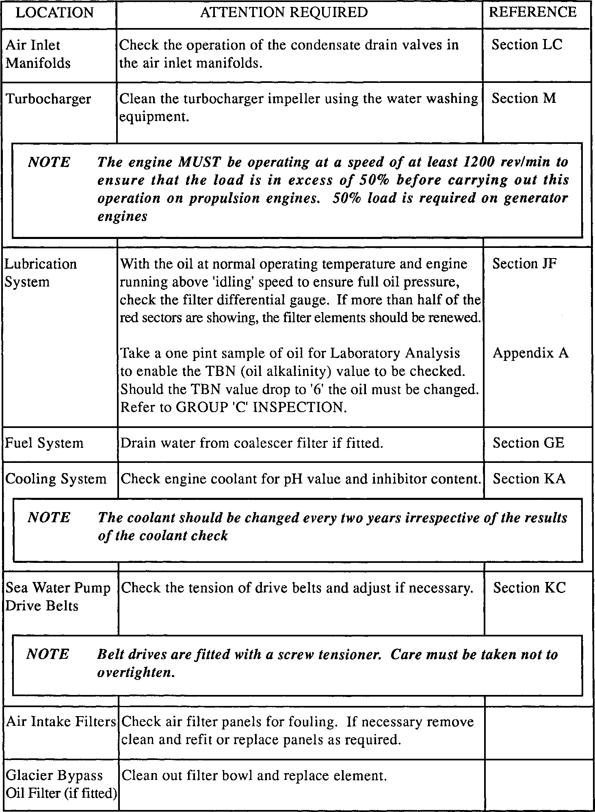

(LEVEL 2)

(LEVEL 2)

|  |  |  |
| --- | --- | --- |
| LOCATION | ATTENTION REQUIRED | REFERENCE |
| Overspeed Trip Mechanism | Check for correct operation as follows  With the engine stopped, adjust the overspeed trip unit to the 'LOW' setting. Start engine, slowly increase speed, and note the speed at which the TRIP UNIT operates to 'STOP' the engine and compare with the figure quoted in the Engine Test Sheets. DO NOT EXCEED NORMAL ENGINE OPERATING SPEED.  Readjust the overspeed trip unit setting to 'NORMAL' and reset the governor. | Section HD |

(LEVEL 2)

|  |  |  |
| --- | --- | --- |
| LOCATION | ATTENTION REQUIRED | REFERENCE |
| Cylinder Heads | Check tappet clearances and adjust if necessary. Check for broken valve springs. | Section FA |
| Lubrication  System | Drain the engine oil sump, filter and piping whilst oil the is hot. Refill the sump to the correct level with new oil of the correct grade. Prime the engine lubricating oil system and top-up to the 'MAX STATIC mark on the dipstick. | Section JB |
| NOTE. The recommendation to change the oil every 1000 hours is based on average operational duty. It must be emphasised that the actual change point is dependent on a minimum permissible TBN value of '6' as determined by oil analysis report. | | |
|  | Subject to the differential pressure indicator reading (See GROUP 'A' Inspection), dismantle the lubricating oil filter, clean the casing, fit new elements and re-assemble filter. | Section JF |
| Fuel Injection Pump Control Gear | Lubricate control gear elastic link with clean engine oil. Check all return springs for security and distortion. | Section HC |
| Fuel System | Drain and dismantle coalescer and chip filters. Clean casings fit new elements and re-assemble.  The frequency of element renewal is dependent upon the quality of fuel, cleanliness of the bulk storage tank and the type of primary filter in the fuel transfer line.  Prime and vent system. | Section GE  Section DA |
| Electric Starter Motor and Relay if fitted | Check that carbon brushes move freely in their holders and are free of grease and dust. Check brushes for length. Lubricate the commutator end bearing via the wick type lubricator. Check and if necessary, clean all contacts. | Section NA |
| Flexible  Mountings | Examine mountings for signs of deterioration. Verify stop clearances. | Section U |
| Flexible Pipes | Check the condition of flexible pipes for signs of deterioration. Replace when required. |  |

(LEVEL 2)

|  |  |  |
| --- | --- | --- |
| LOCATION | ATTENTION REQUIRED | REFERENCE |
| Fuel System | Remove fuel injectors, clean, test and reset or fit a replacement set. Before refitting injectors, clean carbon deposits from the bottom of injector housings. Fit new 'O' rings to injector bodies and new copper washers to the injector nozzles. New 'O' rings and sealing washers should be fitted to the inlet connections. Tighten the injector clamps to the correct torque loading and pressure test seals via the injector drain system with a suitable controlled air supply. | Section GH |
| Turbocharger  (Elliot) | Withdraw the turbocharger blower inlet casing and clean the impeller, diffuser and blower casing. Refit using new seals. | Section M |

(LEVEL 3)

|  |  |  |
| --- | --- | --- |
| LOCATION | ATTENTION REQUIRED | REFERENCE |
| Cylinder Heads | Remove cylinder heads, dismantle and clean. Inspect all components for excessive wear. Check valves, seatings and depth of valves in head. Examine coolant passages for scale deposits and water test the cylinder heads. Check that the push rods are not bent and that the cup and ball ends are secure and not excessively worn. | Section FA |
| Piston and Connecting Rods | Remove the piston and connecting rods and check the condition of the large and small end bearings. Measure and record dimensions. Measure and record the vertical clearances and gaps of piston rings. | Section FB |
| NOTE The recommendation to remove all connecting rods and pistons is based  on covering all installations. On the basis of a sample inspection it may be possible for pistons to remain in place in certain installations. | | |
|  |  |  |
| Cylinder Liners | Measure the cylinder liners for wear using the step gauge and record dimensions. It is also recommended that sample liners be withdrawn from the crankcase to check the sealing ring condition. | Section FH |
| Crankshaft (If all pistons removed) | Inspect crankpins, measure and record dimensions.  Check that oilways in the crankshaft are clear by priming with lubricating oil. | Section FF |
| Torsional Vibration Damper and Crankshaft Free-end ’V’ Seal | Remove free-end drive. Remove the crankshaft free-end seal and free-end cover plate. Rotate the crankshaft to bring the damper sampling plugs to the horizontal, remove one plug and take a sample of damper fluid.  Fit and lock plug.  Replace free-end cover plate,using new joints and 'O' rings.  Fit new 'V' seal to seal carrier, re-establish shim/joint combination and fit seal.  Refit sea water pump drive. | Section KC Section FF Section FH Section FG  Section FH  Section FF  Section KC |
| NOTE On some engines a plug may be fitted in the free-end cover plate to allow  a sample to be taken without removing the cover. | | |
|  | 16 and 18 cylinder engines have two dampers but an indication of the condition of both dampers can be gauged by sampling the outer one only. |  |

(LEVEL 3)

|  |  |  |
| --- | --- | --- |
| LOCATION | ATTENTION REQUIRED | REFERENCE |
| Fuel Injection Pump control Gear | Examine the fuel injection pump control gear bearing bushes, ball joints and pump rack connections for excessive wear. | Section HC |
| Turbocharger | Remove from engine, strip and overhaul. | Section M |
| Air Flap Valve | Dismantle and check condition of bearings and seals. Renew as necessary. |  |
| Induction and Exhaust System | Inspect and clean inlet and exhaust manifolds. Pressure test the exhaust manifold. | Section LC |
| Cooling System | Check all coolant passages for scale deposits. Remove thermostatic elements and check for correct operation. | Section KA and KG |
| Lubrication  System | Remove lubricating oil thermostatic elements from free- end cover and check for correct operation. | Section JG |
| Charge Air Heater/Cooler | Clean and inspect air and coolant sides of cooler.  Service in accordance with manufacturer’s instructions. | Section KD |
| Fuel Oil Cooler | Remove from engine and inspect fuel and coolant sides of cooler. Service in accordance with manufacturers instructions. | Section KF |
| Lubricating Oil Cooler | Remove from engine, withdraw tubestack and inspect oil and coolant sides of cooler. Service in accordance with manufacturer’s instructions. Refit to engine using new 'O' rings. | Section KF  Section FH |
| Heat Exchanger | Remove, withdraw tubestack and inspect coolant and salt water sides. Service in accordance with manufacturer’s instructions. |  |
| Engine Governor | Remove from engine, drain lubricating oil and clean magnetic plug. Renew drive shaft oil seal. Refit to engine using a new 'O' ring. Refill to sight glass with new oil of the correct grade. | Section HA |

(LEVEL 3)

|  |  |  |
| --- | --- | --- |
| LOCATION | ATTENTION REQUIRED | REFERENCE |
| Fuel Injection Pumps | Remove from engine and discard all cam box 'O’ rings. Renew fuel rack seals and check pump calibration. If suitable calibration equipment is not available, the pumps should be returned to the manufacturers. Refit to engine using new cambox and non-return valve 'O' rings. | Section GG Section GF  Section GG |
| Fuel Limiter and Overspeed Shutdown Unit | Remove from engine, dismantle and service as necessary. Renew all 'O' rings and joints. | Section HB |
| Overspeed Trip | Remove overspeed trip governor,dismantle and service as necessary. Renew all joints and 'O' rings. Remove drive unit, dismantle and examine drive spring for deterioration and collapse. Renew if necessary. | Section HD |
| Fuel Feed Pump and Drive | Remove fuel feed pump, dismantle and service as required. Renew all joints, seals and 'O’ rings. Remove drive unit, dismantle and examine drive spring for deterioration and collapse. Renew if necessary. |  |
| Engine Coolant Pump | Remove from engine, dismantle and renew oil seal. Examine impeller rotary seal for damage and renew if necessary. Reassemble and refit to engine using new 'O' rings. | Section KB |
| Salt Water Pump | Remove from engine, dismantle and renew impeller rotary seal, grease seal and bearings. | Section KC |
| Starter Motor | Remove from engine, dismantle and service in accordance with manufacturer’s instructions. | Section NA |
| Starter Ring | Inspect for security and damage. |  |
| Alignment of Set | Check alignment of set by taking and recording crankshaft deflections. | Section FF |

GROUP 'F' INSPECTION (12000 or 20 years).  
(LEVEL 3)